The Relationship Between Foraging Behavior and Offspring Size in Lizards

Samuel Shrewsbury

April 4th, 2023

**Introduction**

Offspring size is one aspect of an organism’s traits that is important for determining future success and survival. Size of offspring can be influenced by many including diet and foraging method. The way an animal forages is one element that has many different outcomes such as altering behavior, efficiency in completing necessary survival tasks, and the evolution of body shape and size (Huey and Pianka 1981). These elements can change how an animal obtains energy to have the best reproductive output and provide the best chance for the future generations advances.

Foraging behavior differs depending on the type of diet each organism consumes. In lizards, some categorizations include widely foraging, sit and wait behavior, and a mixture of the two (Padilla Perez et al. 2022). These foraging types may have evolved through natural selection in addition to how well it benefits the species in regards to the energy spent gathering sustenance (Anderson and Karasov 1981). Each differing species of lizard will have a preferred foraging method depending on what it eats and how much energy it is willing to invest. Widely foraging lizards tend to spend around 1.5 times more energy than a sit and wait species; however, the energy gained can be as high as 2.1 times higher than the sit and wait foragers (Huey and Pianka 1981). This energy expenditure and gain may have an important role in the evolution of offspring size based on what foraging mode is displayed.

**Materials and Methods**

The data used to examine foraging mode and offspring size in lizards comes from Padilla Perez et al. 2022. There were 600 species compiled from published works that were used in determining how offspring size correlates with foraging methods. However, Padilla Perez et al. 2022 used only 485 species of lizards in their analysis of reproductive effort associated with foraging modes and their phylogeny. The offspring size, in grams, was used for all 600 species listed and then based on three different foraging types: widely foraging, sit and wait, and mixed.

Analysis of offspring mass in regards to foraging type was calculated using version 4.2.2. of RStudio. A one-way analysis of variance (ANOVA) was used with the 600 species of lizards based on the three foraging modes with solely the offspring mass to see if there were any significant differences. A student’s t-test was then used to see which of the foraging methods varied from the other types. A boxplot was also made using R which shown the average offspring mass with the outlier masses based on the three foraging types which will be referred to as Figure 1.

**Results**

Foraging modes produced a different average of offspring mass for each of the three categories. The highest average offspring mass was found to be the widely foraging method that had an average offspring mass of 105.7g mass while the lowest average came from sit and wait at 83.67g average (Figure 1). The middle foraging type, mixed, produced an average of 90.57g. However, each of the foraging methods had a different amount of species that were used to calculate the previous listed averages. Widely foraging offspring mass average was calculated using 265 different species with sit and wait and mixed having 269 species and 66 species respectively.

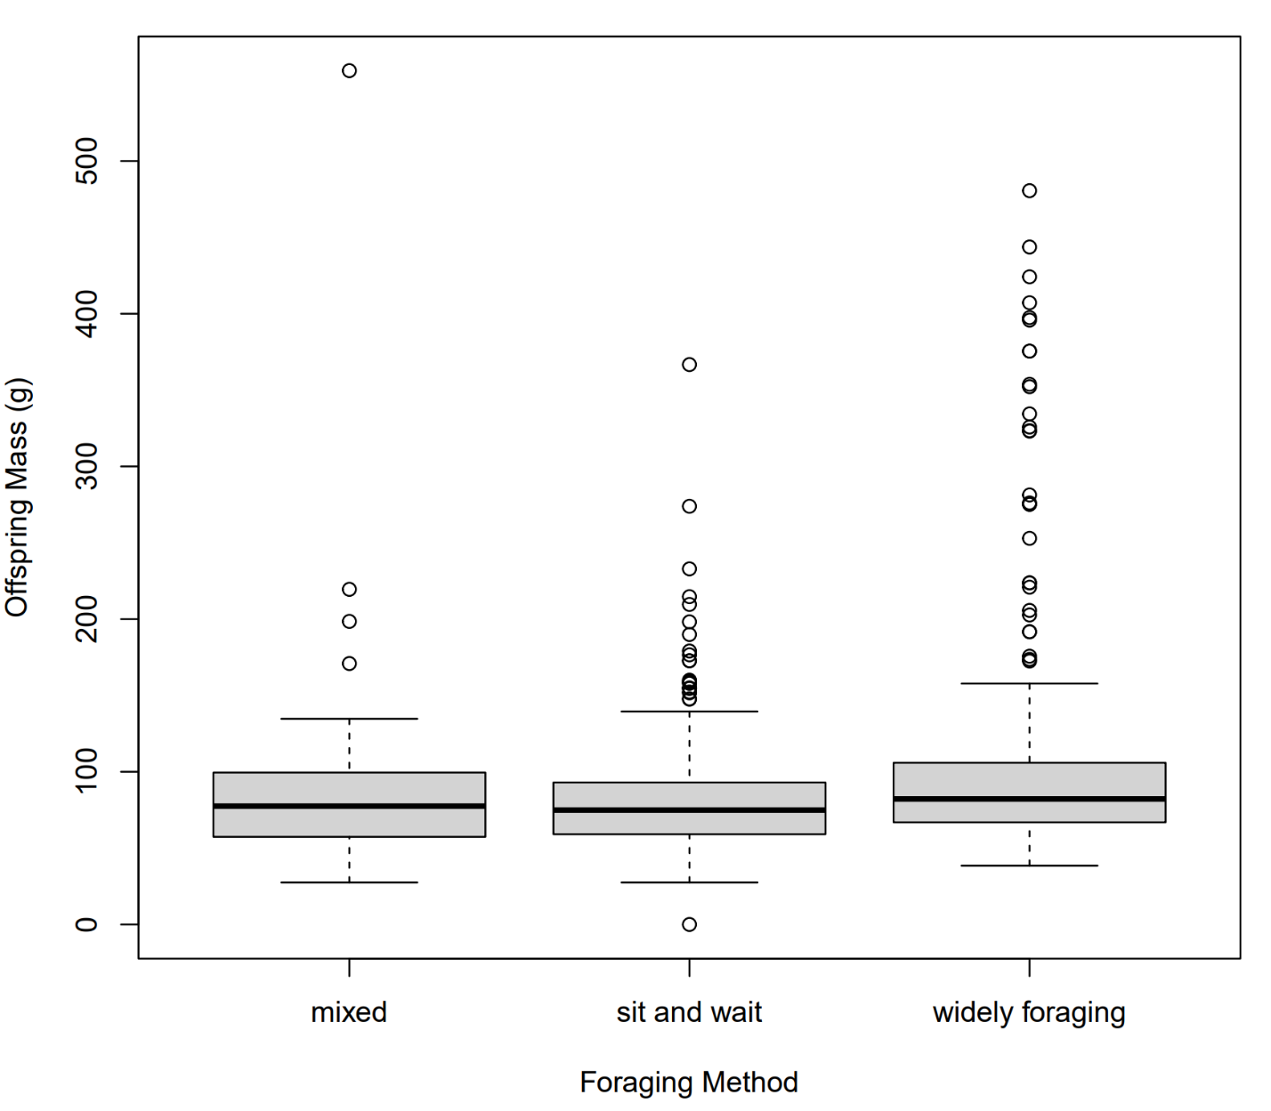

**Figure 1:** The offspring mass of lizards, in grams, categorized on the three types of foraging methods

An ANOVA was also used in testing the correlation between foraging modes and offspring and calculated in R. Based on the 600 total species used from Padilla et al. 2022, it was found that the F value came to be 8.491 using the one-way ANOVA with the critical F value being 3.011. A phylogeny was also created depicting the three lizard foraging types as well as major clades and divergence time measured in millions of years represented by Figure 2 (Padilla Perez et al. 2022).

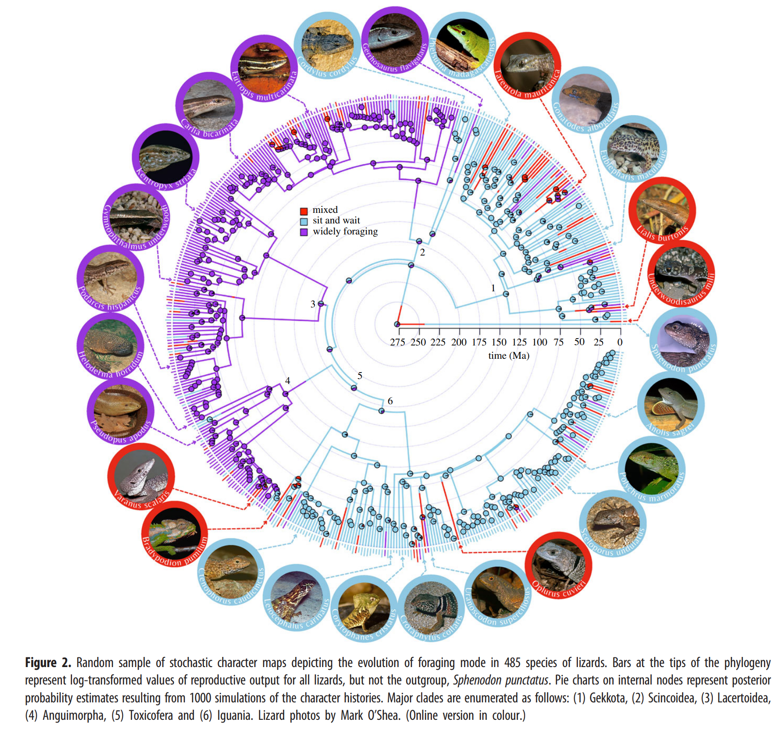

**Discussion**

Based on the ANOVA for 600 species categorized in three different foraging methods, the critical F value comes to 3.011 using a probability level of 0.05. Using the calculated F value from the ANOVA of 8.491, it shows there is a significant difference between the foraging modes and offspring mass. Based on furthering testing used an unpaired student’s t-test, it was found that the difference between foraging modes is between the sit and wait behavior and the widely foraging method. This may suggest that the two different foraging types, sit and wait and widely foraging, have evolved differently over the millions of years depicted in Figure 2. However, further testing and larger samples may be needed to establish a certain understanding in how foraging behavior correlates with offspring size.

Padilla Perez et al. 2022 listed 600 species but tested their reproductive effort hypothesis based on only 485 out of the 600 species. In addition, the sample size for each of the foraging behaviors had various number of species. Sit and wait species had 269 individuals while the widely foraging and mixed types had 265 and 66 species respectively. An analysis with a more similar number of sampling and species count may more accurately depict how the foraging mode impacts the offspring size. In addition, more factors such as energy used and predator encounters as well as numerous other factors could be considered which may support or alter the findings. Based on the previous analyses though, it appears that the widely foraging lizards have evolved differently over the millions of years than that of the sit and wait foraging method lizards.

**References**

Anderson, R. A., and W. H. Karasov. 1981. Contrasts in energy intake and expenditure in sit-and-wait and widely foraging lizards. Oecologia 49:67–72.

Huey, R. B., and E. R. Pianka. 1981. Ecological Consequences of Foraging Mode. Ecology 62:991–999.

Padilla Perez, D. J., D. F. DeNardo, and M. J. Angilletta Jr. 2022. The correlated evolution of foraging mode and reproductive effort in lizards. Proceedings of the Royal Society B: Biological Sciences 289:20220180. Royal Society.